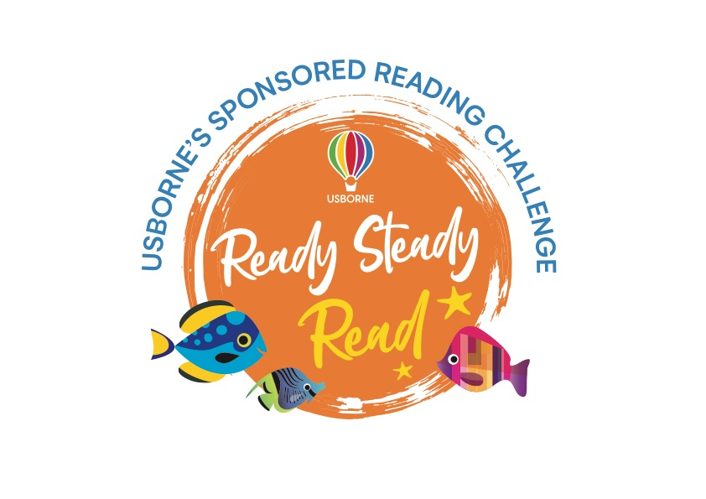

Dear Parent/Guardian,

To celebrate and encourage a lifelong love of reading at home and school, we are running a sponsored read between 4 – 10 March.

The project is being organised in conjunction with our local Usborne Partner, Jane Ireland, and all the money raised will go towards brand new books for our school. In addition to the sponsorship money, Usborne will also donate up to 60% of the total raised in EXTRA FREE BOOKS to the school. So, for every £600 raised, we will get an extra £360 in FREE Usborne books!

Our target is to raise £620 in sponsor money, with Usborne donating an additional 60% of books for free. This will give us a total of £960 to spend on new books and resources for our children.

Please help us to enhance our reading resources for pupils by encouraging your child to spend a small amount of time each day either reading to themselves, to others, or being read to. They can read books, comics, magazines, newspapers, menus, websites, recipes, poems, leaflets, instructions – anything with words!

If you are able to support our sponsored read, please find enclosed a sponsorship form and reading log for your child if they wish to use it to record their reading. Sponsorship money can be paid via JustGiving here by 22 March.

We look forward to having lots more books for your child to read, share and enjoy.
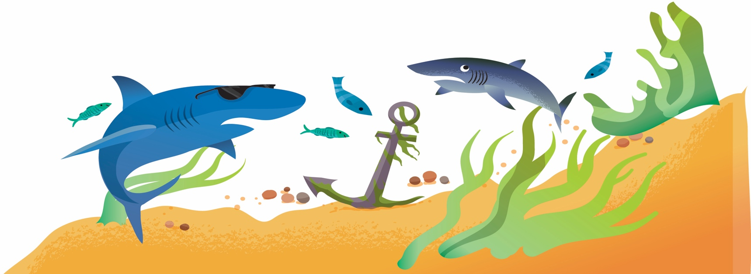
For more information, please contact: Jane Ireland @ jane@quackquackbooks.co.uk.

