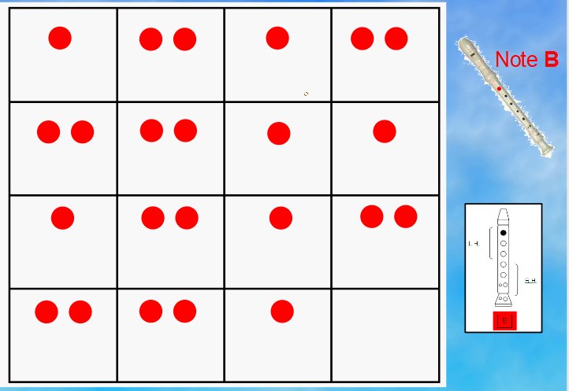

Remember that your left hand goes at the top to play the note B

