Year 3 Spellings Spring : Week 11 24.03.2023
All words this week are homophones
1 | great | Handwriting guide  Use syllables and the sound buttons to help you.  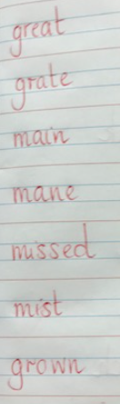
2 | grate
3 | main
4 | mane
5 | missed
6 | mist
7 | grown
8 | groan
Statutory words!
1 | length
2 | library
3 | material
4 | medicine
5 | mention
Green: Just learn the green words and statutory words write them into 5 sentences.
Blue: Learn all the words and write them into 6 sentences.
This week children will be tested on either:-
Green: Tested on 12 words in total.
Blue: Tested on 15 words in total.
AND two unlisted words based on the rule.
Spellings: Write each of your words 3 times on your handwriting sheet using the guide above to help you remember how to spell them.

Choose and use both spellings of the homophones in your sentences this week to show that you understand the meaning. The focus this week in on your handwriting especially after parents evening!
eg The great giant wanted to grate the cheese onto his pizza!

Remember to make sure you are writing neatly and using all appropriate punctuation.
Arithmetic
- Log in to Mathletics.com (direct link: https://community.mathletics.com/signin/#/student) and complete the assigned activities which we have set for you.  - Make sure you learn the 5 times table. Easy peasy? Then you will find telling the time straight forward!  Practise the inverse: 3 x 5 = 15  15 ÷ 3 = 5  15 ÷ 5 = 3 |  |  | 5 Times Table  1 x 5 = 5  2 x 5 = 10  3 x 5 = 15  4 x 5 = 20  5 x 5 = 25  6 x 5 = 30  7 x 5 = 35  8 x 5 = 40  9 x 5 = 45  10 x 5 = 50  11 x 5 = 55  12 x 5 = 60

