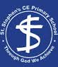

Year 3 – Light and Shadows (January 2023)
LO: To investigate what shadows are and why they are formed.
LO: To investigate how shadows behave
LO: To investigate how the size of shadows change throughout the day.

This term year 3 learnt about how shadows are formed, and how they change depending on where they are in relation to their source of light. At the start of the session the children made a mind map of all that they knew about light and shadows. They then investigated how to form shadows by placing translucent, transparent, and opaque objects in the path of a torch and seeing what happened.

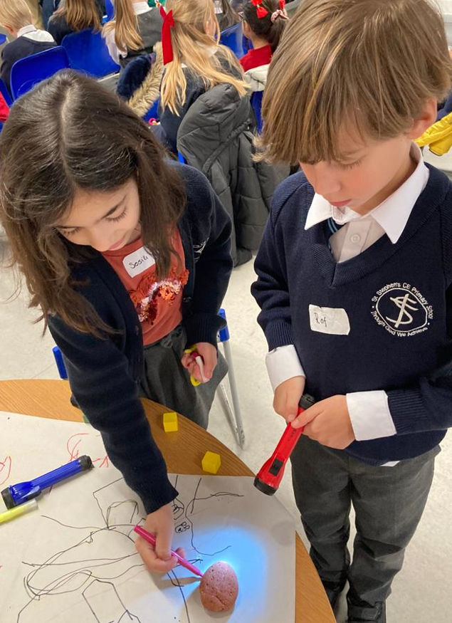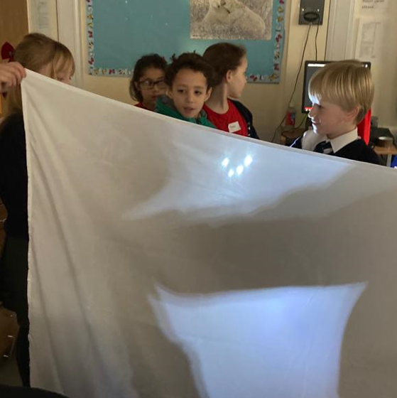
Once they had discovered that shadows are caused by opaque objects blocking the path of the light, we then investigated how shadows change during the day as the sun changes position in the sky. Little stick people made out of pipe cleaners had the “sun” (a torch) shone on them from different angles to simulate the path of the sun, with shadows being drawn to see the difference. Longer shadows were seen in the ‘morning’ and ‘evening’ when the ‘sun’ was lower and at ‘midday’ the shadows were very short.

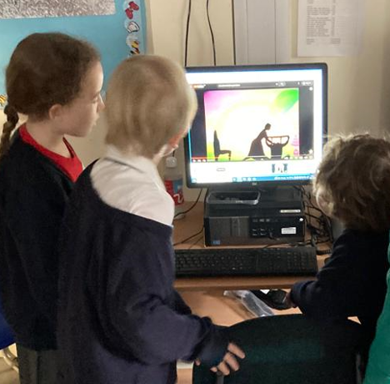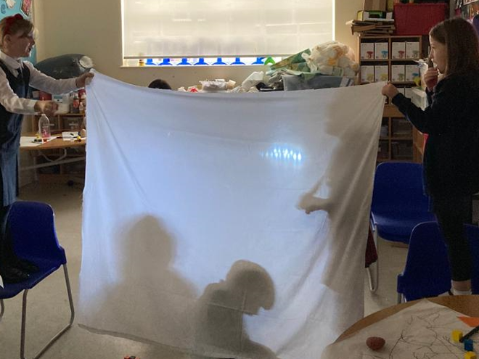

We then look at how shadows behave. Opaque objects were placed on a piece of paper, and a torch was shone on the object to create a shadow. The torch was then moved to a different position or moved closer to or further away from the object to see how the shadow changed. We discovered the shadow changes with the position so that it always is in the opposite direction to the light and shadows get larger as the object and light get closer together.

Finally, it was time to use all their new knowledge to perform in the shadow theatre! Using torches for light and a sheet to create shadows, the children acted out a story, including the three little pigs, red riding hood and jack and the beanstalk!
Kind regards, Miss Kelly & Mrs Wordsworth – Science Co-ordinators

