Y3: Rocks and Fossils Workshops with Mercedes
School Scientist-in-Residence: SIR, Autumn 2022

- LO: To explore soil and how it is formed
- LO: To explore what fossils are and how they are formed

This term, Year 3 have been learning about rocks and fossils. In their special SIR session, the children looked at how fossils are formed using bread (as layers of soil) and sweets (as plants, animals, and dinosaurs). Sweets were placed between 5 layers of bread then crushed under large boxes and left. The students then moved onto making their own fossil casts. Using plasticine as a mould, they pressed their chosen ‘fossil’. Plaster of Paris was poured into the moulds and left to set. This was to model the possibilities that fossils casts may be required when empty spaces or broken fossils are found.

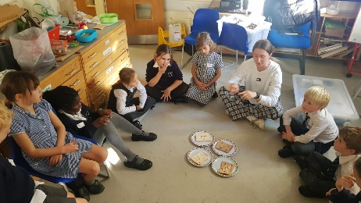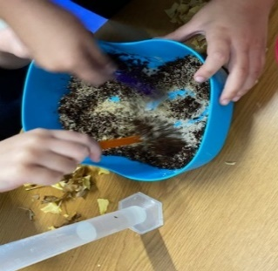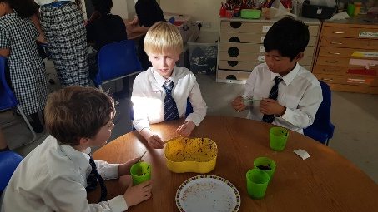

The next task was to explore soils. Various proportions of clay, sand, dirt, and water were mixed by groups then split among the groups to classify. The children discussed where each of the materials could have come from, and what was missing from the soil, such as bugs, worms, and wood. The soils were classified on how they felt, looked, and smelt. Their compiled list of adjectives was written on the whiteboard to act as a prompt. Finally, we returned to the fossilised sweets, removing the boxes to look at what was underneath. Each of the layers of bread were slowly peeled back to reveal the sweets underneath. They looked at how each of the different sweets had left its mark on the bread, and what had happened to them due to crushing. They then selected a piece of bread so the other children could use all their knowledge to identify the sweets that had been on it. The easiest to identify the M&M’s, which had left their colour on the bread!

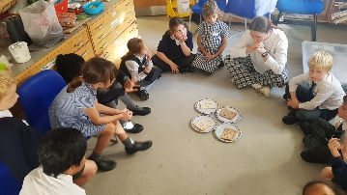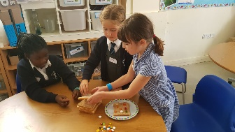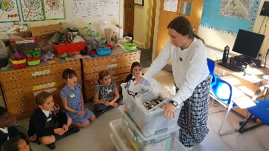
Comments from our Year 3’s after the session;
“I loved mixing the different soils together and working out the recipe.”
“When you press the bread together with something heavy it leaves an imprint – just like a fossil.”
“I liked learning about the different jobs of scientists studying rocks and fossils like Chris Jackson, the geologist.”

