ARTS WEEK 4th March 2022
Well Class Bloom have had a very creative and busy week as I am sure you would imagine when St Stephens host’s a week such as Arts Week – based on the works of the artist Fahrelnissa Zeid . Following on from our D & T Day last Friday the children have had a packed art filled week, with World Book Day thrown in the middle for good measure. So what have we been up to?
Monday- Arabian Nights and the Jungle Book.
On Monday we looked at the tales of the Arabian Nights – a book steeped in the Middle and Far East cultures and a popular muse for the artist. The children had a choice of one of a tale such as Aladdin or Sinbad and recreated the story as a storyboard/cartoon. Such as the photos below.
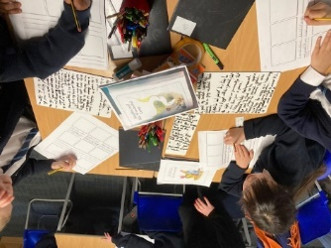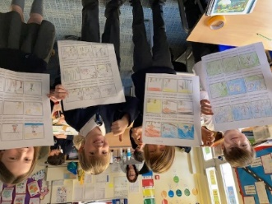
Then in the afternoon we had a traveling theatre production of ‘The Jungle Book’ as a prelude to World Book Day later in the week. We have a production such as this every year in Arts Week and it is yet another reason to be thankful for all the funds raised by you, the parents, each Year.
Tuesday- Dried Food Mosaics
Mosaics can be tricky but always are worth it in the end and these pieces by your children were no exception. The children choose a pattern and then using PVC glue began to stick assorted dried food items in the shapes on the page. The food items included pasta, lentils, rice, peas, beans and other foods I had not even heard off. Working to ensure the work stood out, the children carefully applied the items and then left the pieces to dry out overnight. Have a look at the photos here and above and tell us what you think.
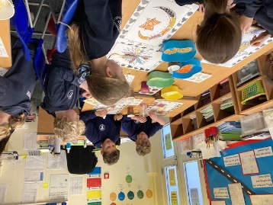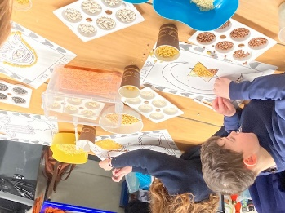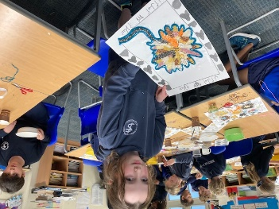
Wednesday – Colorful windows
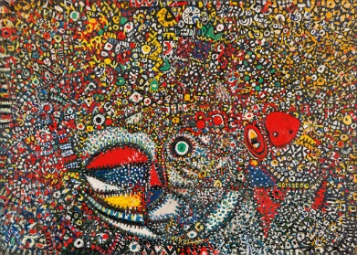
A big feature of Fahrelnissa Zeid’s work is her use of bright and vivid colours. Like the two painting below, some of her pieces are simply an explosion of a variety of such colours. We looked to replicate that to a smaller degree. The children first drew a rectangle in their books, and then drew lines, sometimes straight and sometimes curved. Sometimes from top to bottom and sometimes from side to side. As the lines crossed each other they created windows or shapes and the children were to ensure each part was to be coloured in similar bright and vivid colours like Elsa’s picture. I also wanted them to see if they could create a shape or figure within. Can you see them in Enkhjin, Hector and Marlon’s work below? What do you think about the colours used?
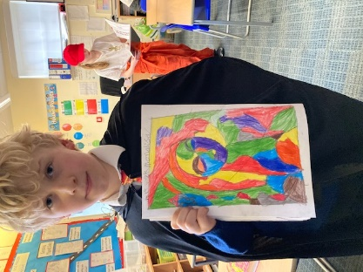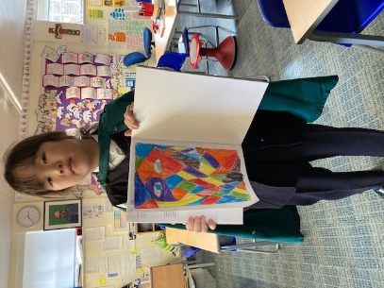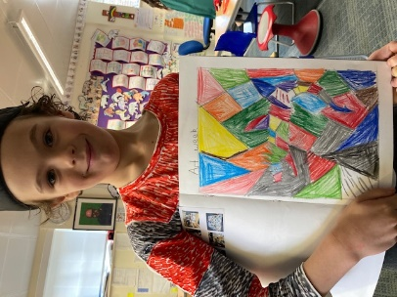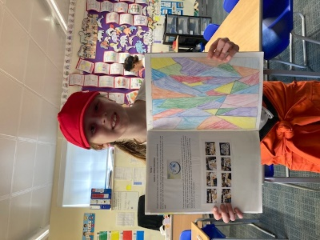
Thursday- World Book Day and Potato Pressing
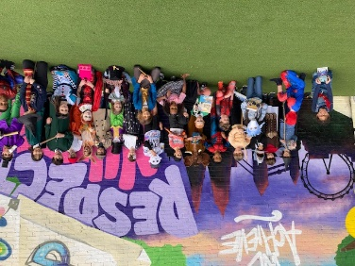

Well today was of course ‘World Book Day’ and the class was just abounding in Willy Wonkas, Harry Potters and Spider Men (three of each) along with centaurs, elephants, kangaroos, Tin Tins, Sherlock Holmes and many more. We created a front page for our favourite books and played a book name game. While all this happening we also had another fun activity – that of potato pressing. This was …well pressing potatoes that had been cut into different shapes and dipped in paint to create patterns on the paper provided for the children.

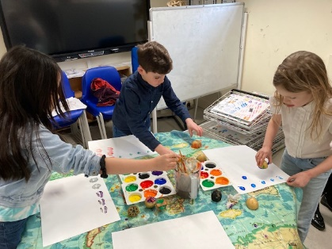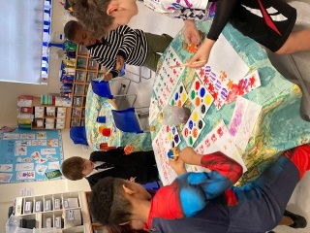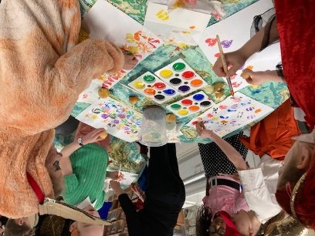

Friday – Stainglass (or Tissue) Windows.
As a practising Muslim and Princess of Turkey, many of the themes of Fahlrelnissa Zeid’s work had an Islamic theme. Be they Islamic pattern work, mosaics or the painting of a mosque. Firstly today, focusing on Zeid’s style of vivid colour, we stayed with that theme with another example of colour such as this- stainglass windows. Instead of using paint or colouring pencils we cut out the frames of a window and then filled in each section using brightly coloured tissues. You can see some finished results below.
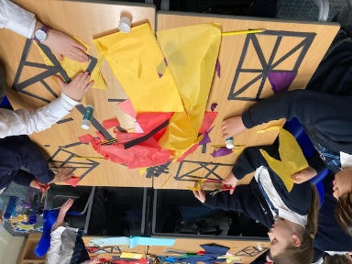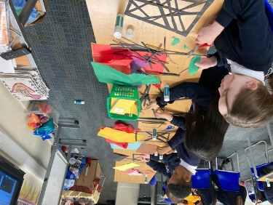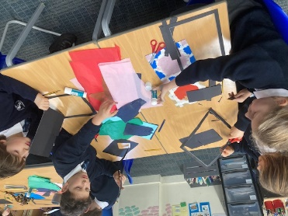
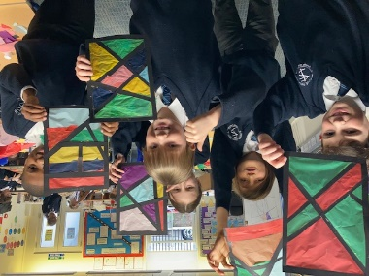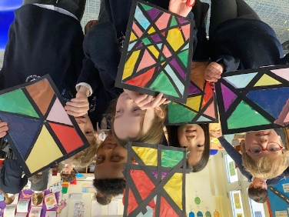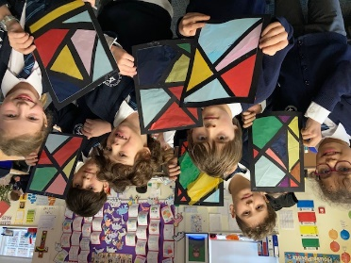
Mosque by Night
Then in the afternoon we acknowledged Zeid’s Islamic faith by drawing and painting a mosque in a colourful setting. We used oil paints to gently shade a sunset or sunrise setting and after this we drew an outline of a mosque in silhouette then painted it black.

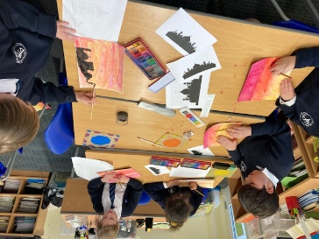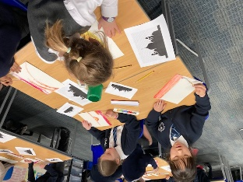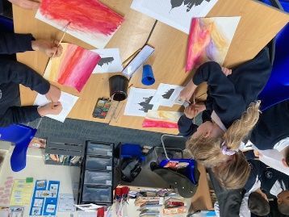

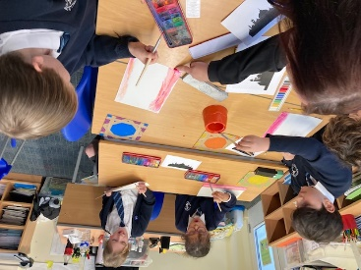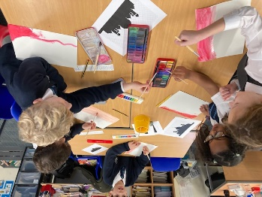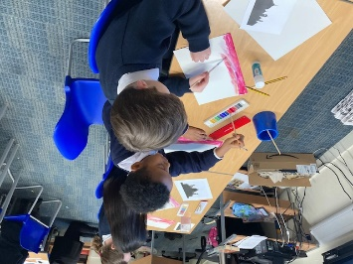

It has been a wonderful all-round week and massive thanks should be given to Mrs Cummins, Miss Lisa and Miss Tami for all their hard work in making it happen.

