7.01.22
English, history and science topic words
1 | knight | Green: Just learn the green words and write them into 5 sentences.  Yellow: Learn the green and yellow words and write those 5 into sentences.  Blue: Learn all the words and write those into 5 sentences.  Remember you may need to look some of these words up in a dictionary so that you know what they mean for your sentences!
2 | night
3 | castle
4 | village
5 | palace
6 | daughter
7 | prince
8 | princess
9 | soldier
10 | armour
11 | vertebrate
12 | invertebrate
13 | amphibian
14 | environment
15 | classification
Spellings:
Practise your spellings words with a handwriting focus – identifying ascenders and descenders (tall letters and letters which go below the line).

Draw an outline around your spellings words which identify the shape of the letters.

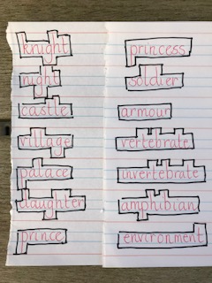

Next week – we’ll have a short quiz to see if you know the spelling word from just the outline.

Reading Comprehension – The Dragon’s Egg

Mathletics tasks to be completed.

