2.2.22
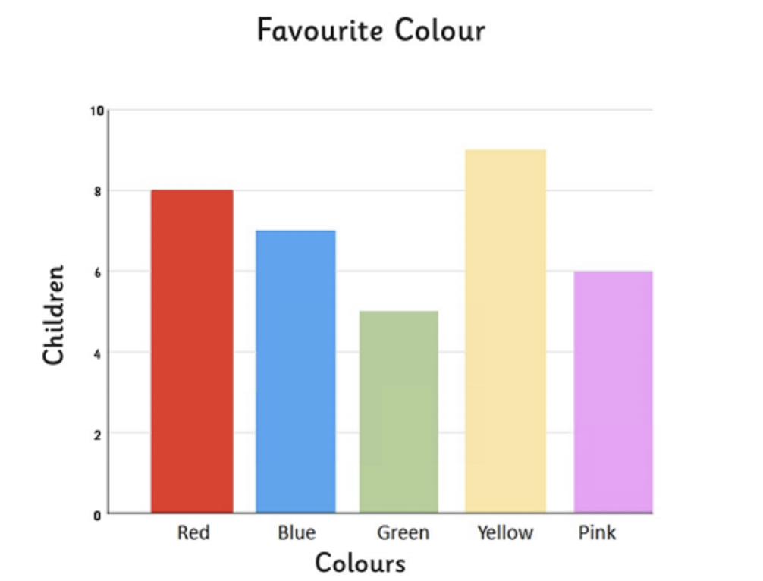
LO: To answer questions about the data in a bar chart

Answer the following questions.
- What is the least favourite colour?
- How many children chose yellow as their favourite colour?
- How many fewer children chose green than blue as their favourite colour?
- How many children altogether chose pink and red as their favourite colour?
- How many more children chose red than pink as their favourite colour?
- How many children chose yellow, pink and green as their favourite colour?
- How many fewer children chose green than yellow as their favourite colour?
Extension: Have a go at the ‘Challenge Cards’. Do as many as you can! Start with the cards with one chilli and work your way up to the really spicy 3 chilli one! Good luck!

