Name:…………………………… 1.2.22
LO: To read and draw simple pictograms and tally charts and answer questions about the data
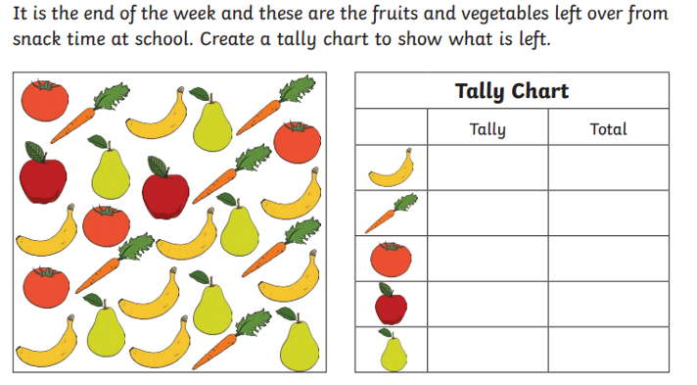
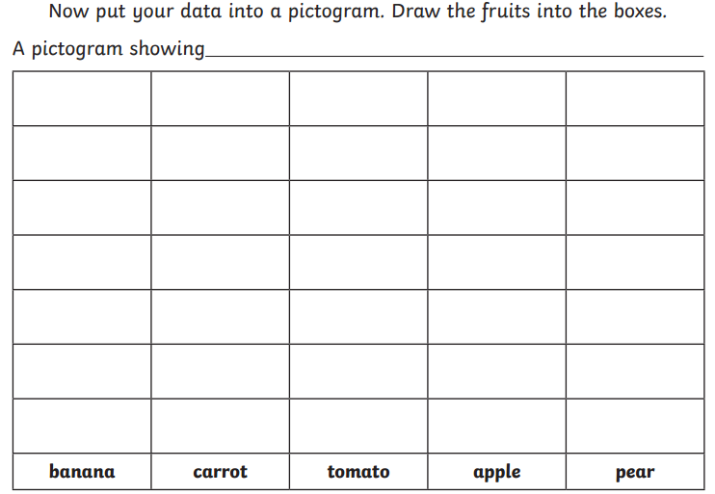

Answer these questions using your tally chart and pictogram:
- How many bananas were left?
- How many pears were left?
- How many tomatoes and carrots were left altogether?
- Which fruit had the fewest number of pieces left?
- How many pieces of fruit were left altogether?
Extension
Which fruit do you think was the most popular that week? (Think carefully about this one!)

