Accessing Busy Things via My USO

Google MYUSO or use this hyperlink.
Once at My USO use your child’s personal log in details. These were sent out via Parentmail.

You should have a library that looks like this:

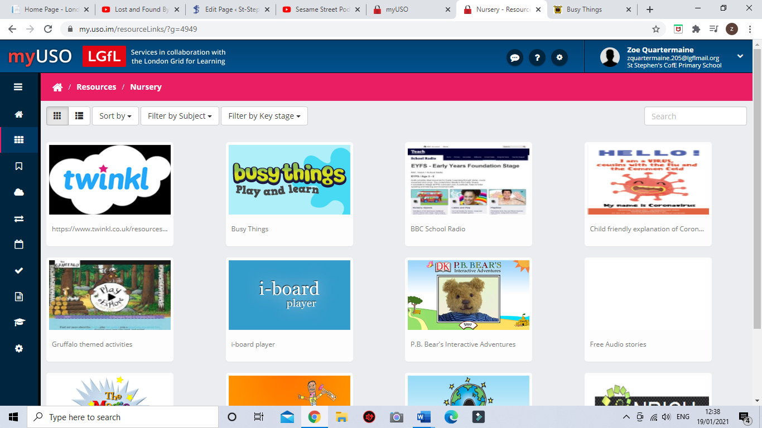

Click Busythings.
Then your page should look like this:

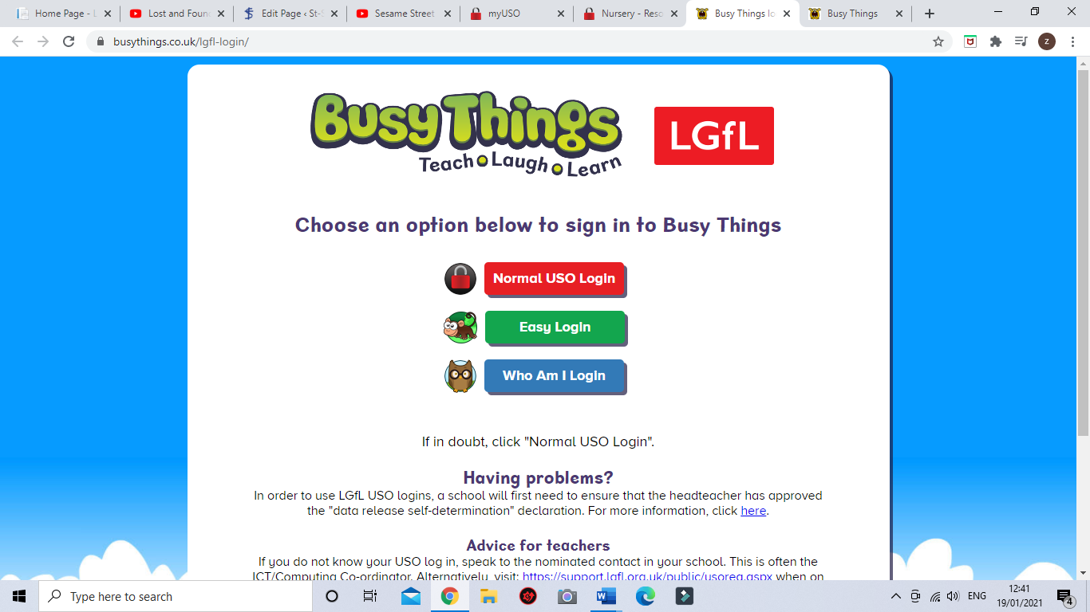

Log in with your MYUSO details.

(Keep scrolling for the next step)

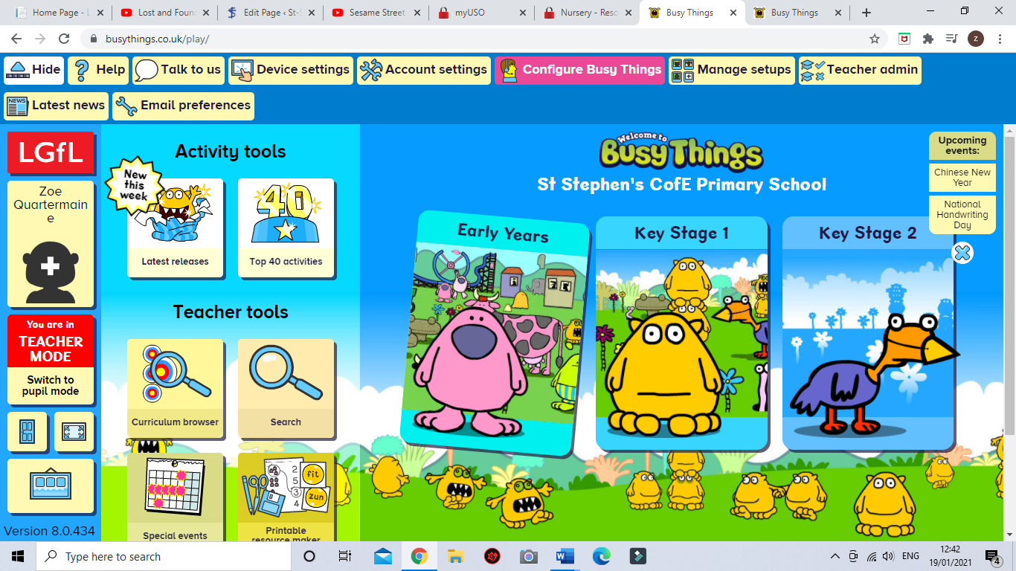
Choose the pink monster: Early Years

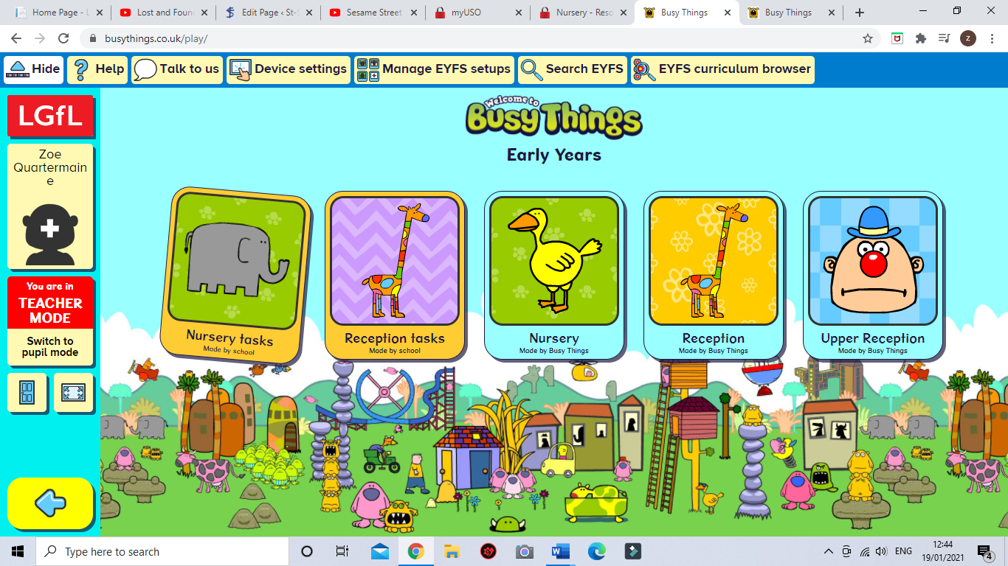

Choose the elephant: Nursery tasks made by the school.

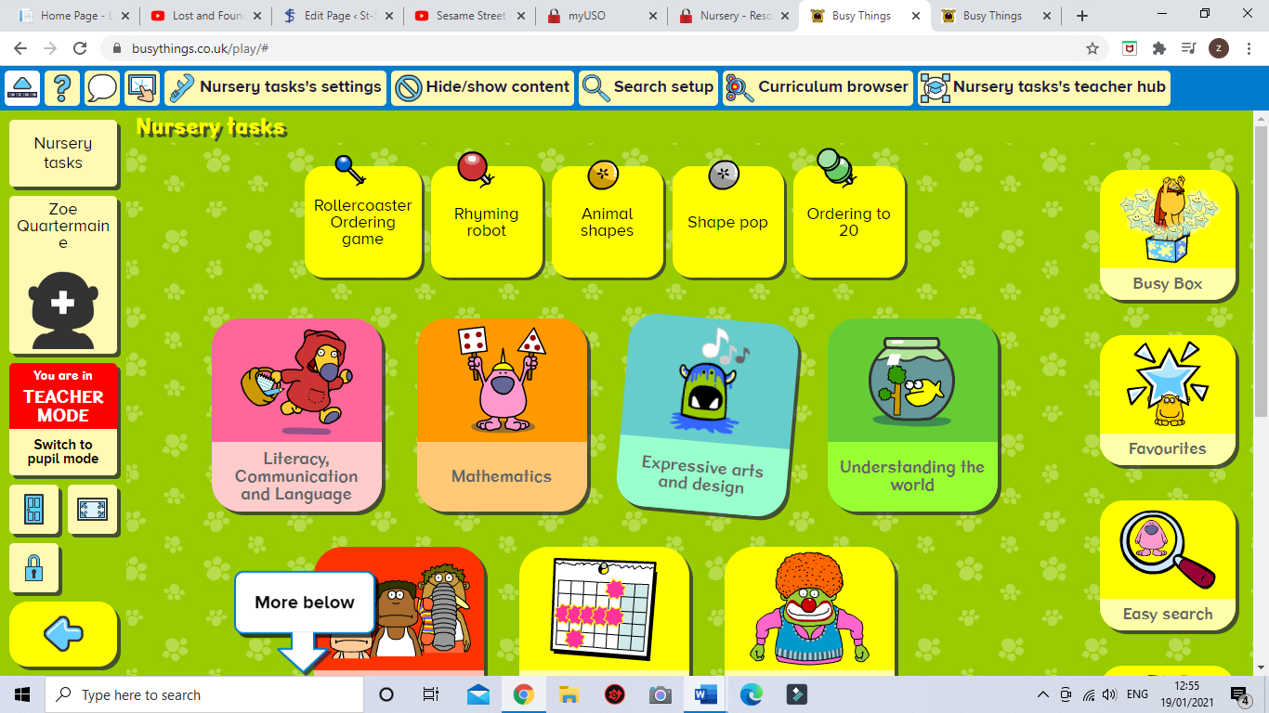

Choose Rollercoaster Ordering game if you’d like to play with numbers 1-9.
Choose Ordering to 20, if you’d like to play with numbers to 20.

