Things I can do to be kind and helpful at home
 | Monday | Tuesday | Wednesday | Thursday | Friday
Get on with playing or an activity by myself for a while.
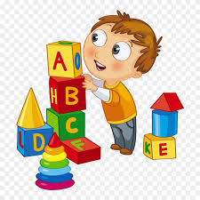
Tidy up as soon as I am asked.
Share with my brothers/sisters or mummy/daddy.
Help brush my teeth.
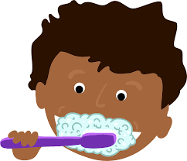

Get dressed by myself.

