Uploading photos of homework onto JIT via phone

- Search for https://my.uso.im/ and login (usernames and passwords can be found in homework books). Click on myuso  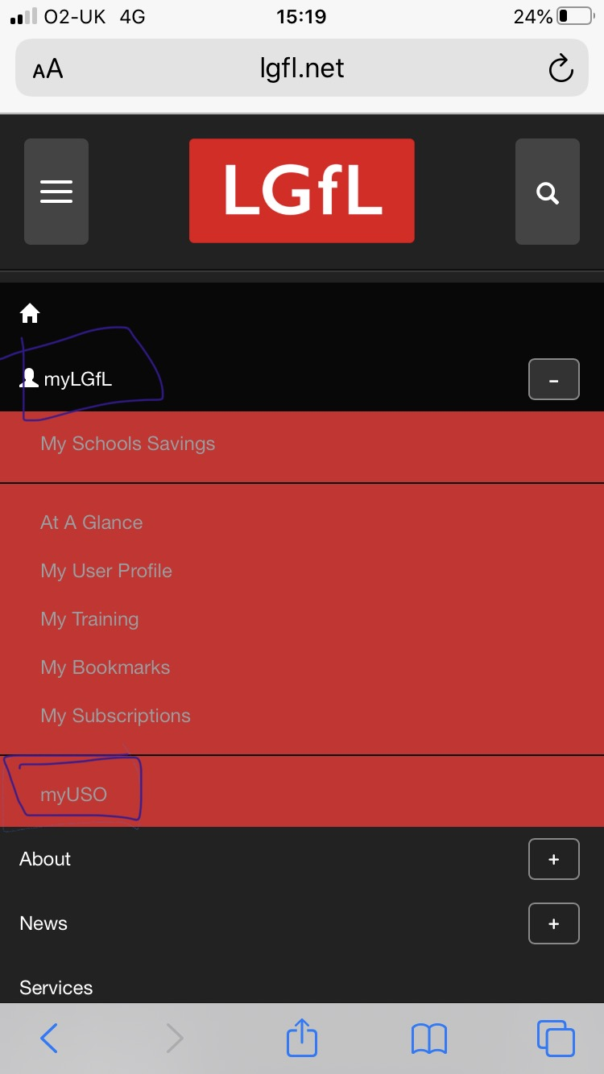 | 4. Click on ‘choose file’  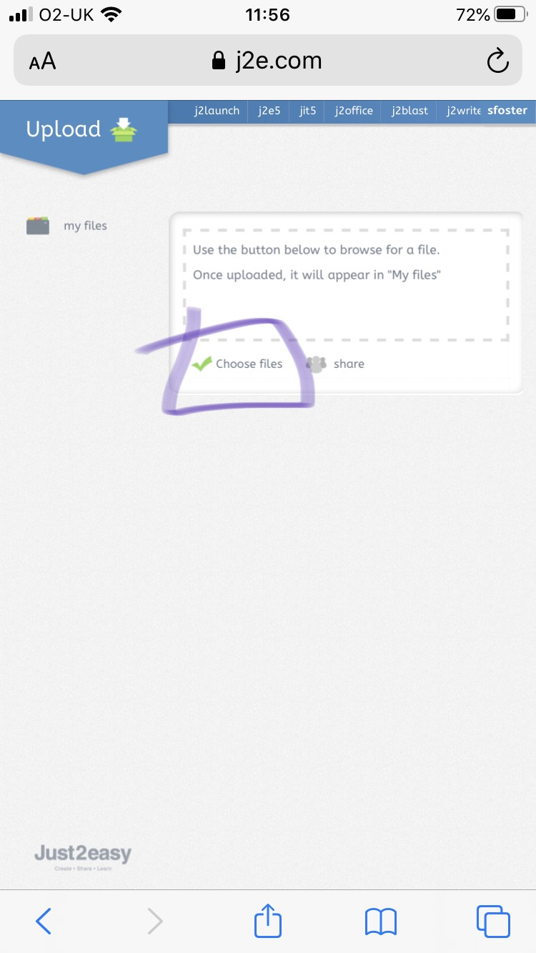
2. Scroll down to JIT  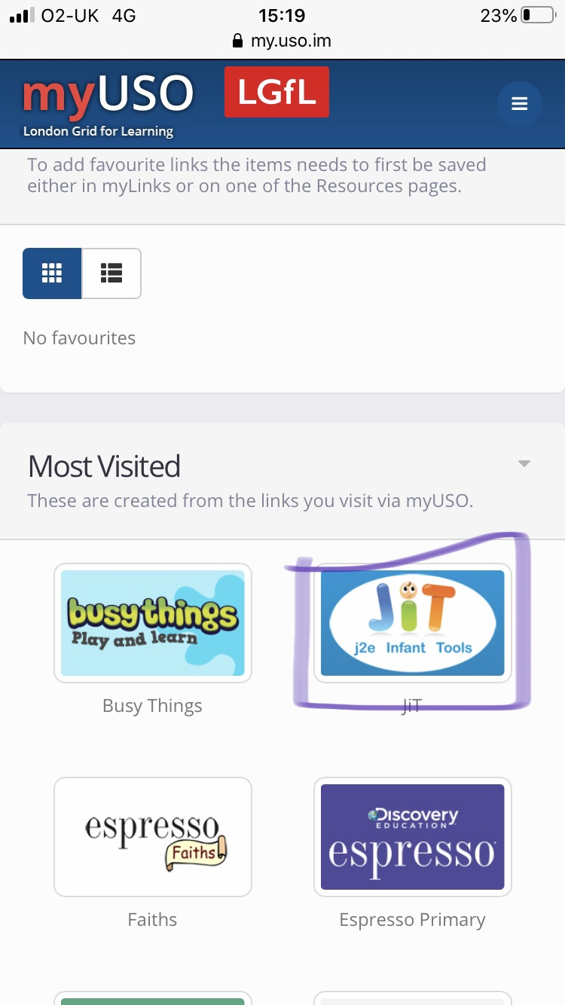 | 5. Click on take photo library  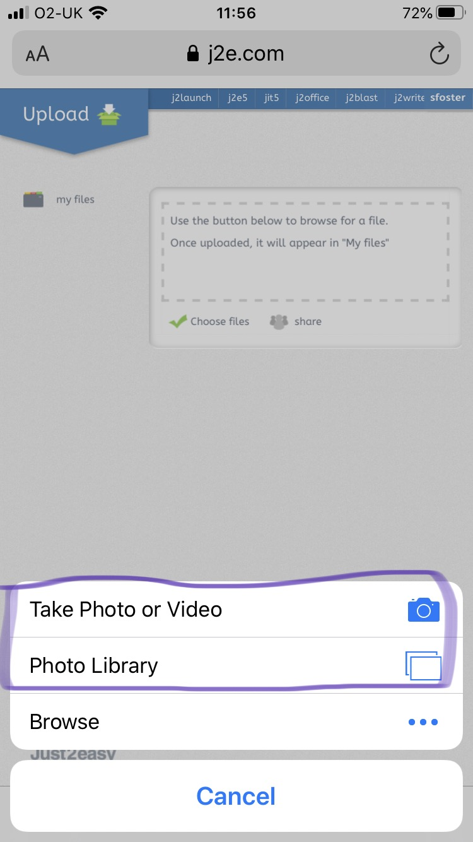
3. Click on ‘My Files’ then ‘Upload Files’  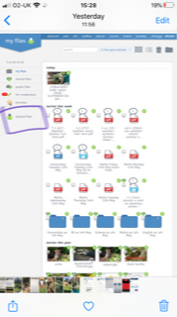 | 6. Go back to My Files where the photo will be uploaded.  