Friday 11th September
Year 1 Donaldson Autumn 1 Poetry Homework
Please practise reading your favourite part of this poem out loud.
Nut Tree
By Julia Donaldson
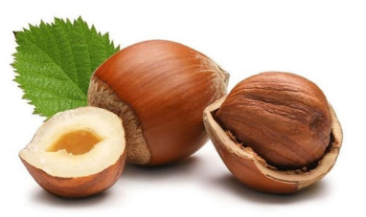
Small, brown, hard, round,
The nut is lying underground.

Now a shoot begins to show.
Now the shoot begins to grow.

Tall, taller, tall as can be.
The shoot is growing into a tree.

And branches grow, and stretch and spread
With twigs and leaves above your head.

And on a windy Autumn day
The nut tree bends, the branches sway.

The leaves fly off and whirl around,
And nuts go tumbling to the ground:
Small, brown, hard, round.

