Uploading photos/work to JIT via phone

1. Login to myuso  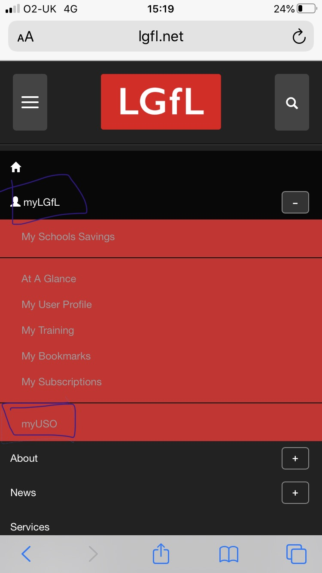 | 4. Click on ‘choose file’
2. Scroll down to JIT  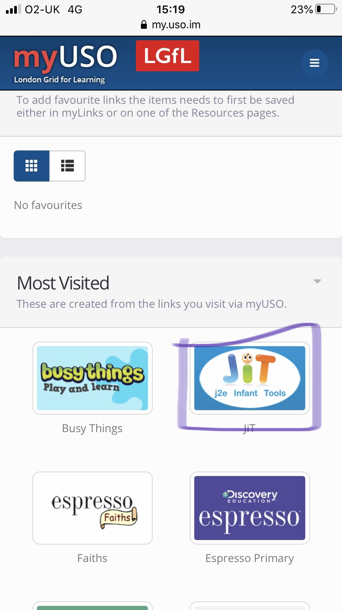 | 5. Click on take photo library  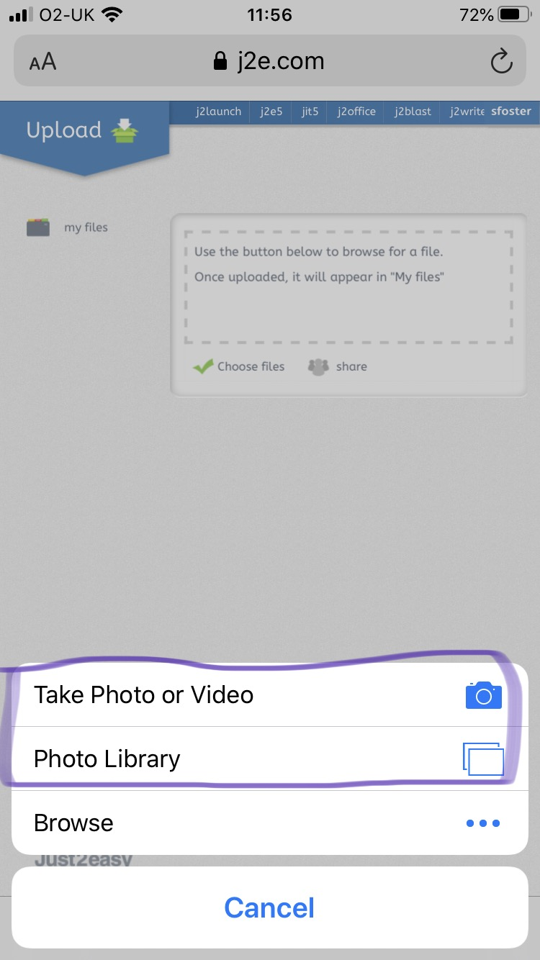
3. Click on ‘My Files’ then ‘Upload Files’  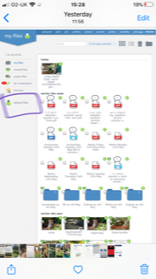 | 6. Go back to My Files where the photo will be uploaded.  