Wednesday 6th May
LO: Identify rhyming words from ‘We’re roaming in the Rainforest’.
Think back to the story ‘We’re roaming in the Rainforst’. Can you match the rhyming words? When you have matched the words, write a sentence using the words, for example ‘Parots sit on twigs and eat figs.’

away | side | twigs | suprise | dare | made
doze | logs | pride | day | sky | figs
eyes | by | frogs | toes | parade | air

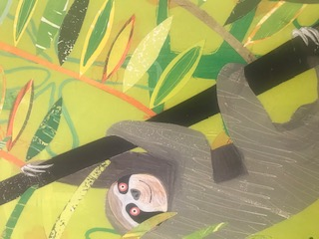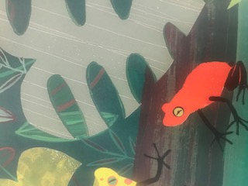
Extension
Can you identify other rhyming words in the story?

