Today’s English lesson is a mixture of Art and English because we would like you to create your own rainforest scene from the story ‘We’re roaming in the rainforest’.

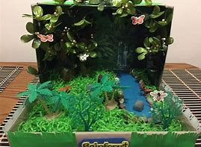
To do this you will need a box, so now is the time to raid the recycling bin! Any size will work, cereal box, a tissue box, shoe box, fruit punnets ect. You’ll also need some felt tips or even better paints to decorate the inside of your box so it looks like a rainforest. Old fabric, tissue paper, old magazines and newspaper are great for this! Once you have decorated your box make animals for your rainforest, you can either draw your own or use the templates below. Then retell the story, saying what each animal is doing using the verb with –ing. For example ‘The yellow, spotted jaguar is growling loudly’.

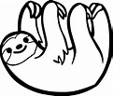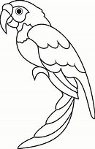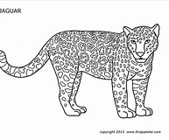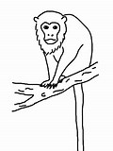

Challenge! Can you add your own rainforest animals?

