We can add –ing to verbs to change the tense, for example walk becomes walking.
Match the root verbs to the –ing verbs.

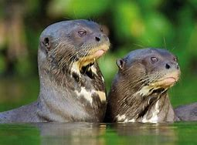  otters | squawking | squawk
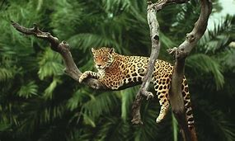  jaguars | chattering | snap
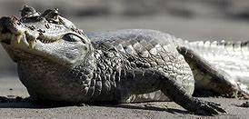  caimans | yawning | whisper
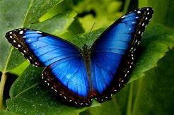  butterflies | murmuring | murmur
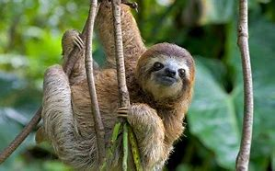  sloths | snapping | chatter
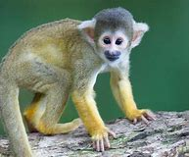  monkeys | growling | growl
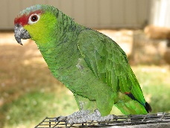  parrots | whispering | yawn

