Nombre: _________________________
Fecha: __________________________

LO: Search for key information in a Spanish video clip. https://www.bbc.co.uk/teach/class-clips-video/spanish-ks2-painting-and-colours/zbcb47h
- Which Hispanic artists does Javier like? Circle the correct answers;
Dalì Frida Kahlo Miro Rivera Picasso El Greco

- Which artists in the clip are Mexican?
Dalì Frida Kahlo Miro Rivera Picasso El Greco

- Which colours does Ashleigh like/ dislike/ love.
Le gusta ______________.
No le gusta _______________.
Le encanta ________________.

- Which other colours were mentioned? Can you list them in Spanish?
____________________________________________________________________________________________________________________________________________________________________________________

- What Spanish grammatical rule did Ashleigh learn about adjectives? Can you give an example?;
____________________________________________________________________________________________________________________________________________________________________________________

- When Sara sees the completed paintings she says ‘iQué fea!, iqué horror!’
Use google translate to find out what this means…..
________________________________________________________________________________________________________________________

- Three parts of the face are mentioned in Spanish. Can you list them in Spanish and English?
________________________________________________________________________________________________________________________

Challenge: Create a portrait in the style of a Hispanic artist- perhaps Kahlo, Picasso or Rivera. You may want to search some paintings by these artists for inspiration. Finish your Hispanic inspired portrait by labelling the parts of the face and colours in Spanish. Remember adjectives come after nouns in Spanish and they always agree.

Ejemplo………..

flores rosas ceja negra
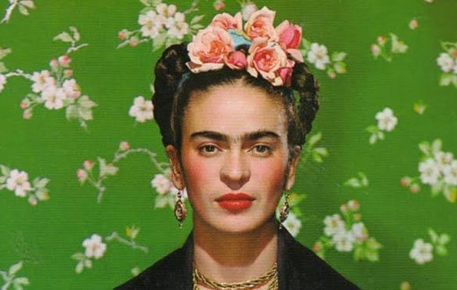mejillas rosas

ochos negros boca roja

