Nombre: _____________________
Fecha: __________________________

LO: To listen for key words in a Spanish Video clip and to identify cultural differences.

- Which of the following means ‘how are you?’. Circle the correct answer.
¿Que tal? ¿Cómo te llamas? ¿Cómo es el clima? ¿Qué hora es?

- What are the names of Sara’s 3 friends and where do they all live?

Se llaman ________________ _______________ y ________________.
Viven en ______________________.

- Javier says ‘No entiendo’. What does this mean in English?

__________________________________________________________

- What do the following expressions mean in English?

Mi barrio ________________________
Hace frío ___________________________
Buenas tardes ___________________________

- What do the children eat in the café? Circle the correct answer….

Guacamole Paella Burrito Churros con chocolate

- Ashleigh introduces her brother. How do you say brother in Spanish? Can you remember what the other words mean? Translate each one into English.

madre hermano abuelo padre hermana

______ _______ ______ ______ __________

Challenge: Imagine that you are meeting a Spanish pen pal for the first time. Make a poster displaying information about yourself in Spanish. Use the word bank to help you.

Word bank Banco de palabras
Me llamo___________ My name is __________
Tengo _________ años I am __ years old
Vivo en ___________ I live in ________
Me gusta ___________ I like ___________
No me gusta ___________ I don’t like ___________

Ejemplo:
Todo sobre mì
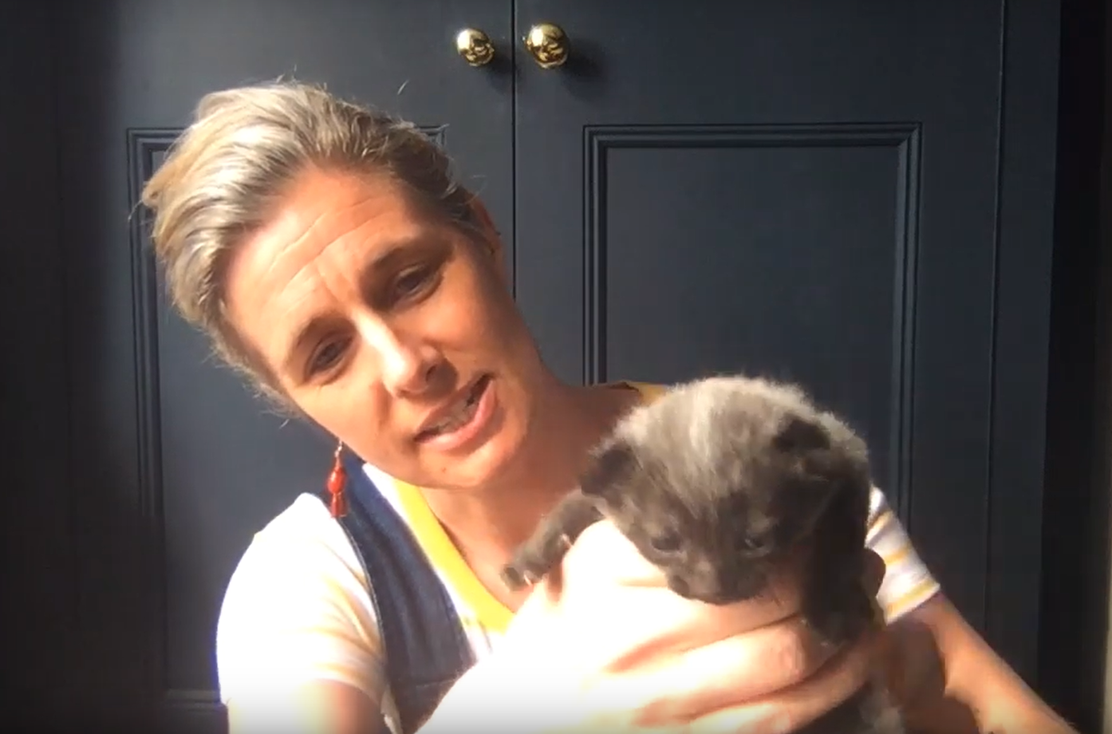
Me llamo Señora Pereira
Tengo treinta y nueve años
Vivo en Shepherds Bush
iMe gusta mi gatito y churros con chocolate!
No me gusta el color marron.

