Nombre: ___________________
Fecha: ____________________
LO: To listen to a Spanish song and respond with the correct greetings.
Watch the clip and join in with the song and actions…… then try to do the work below….
- Match the Spanish greeting to the correct picture….
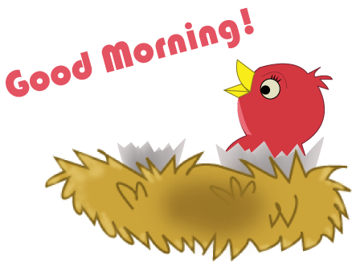  This Photo by Unknown Author is licensed under CC BY-NC |  | 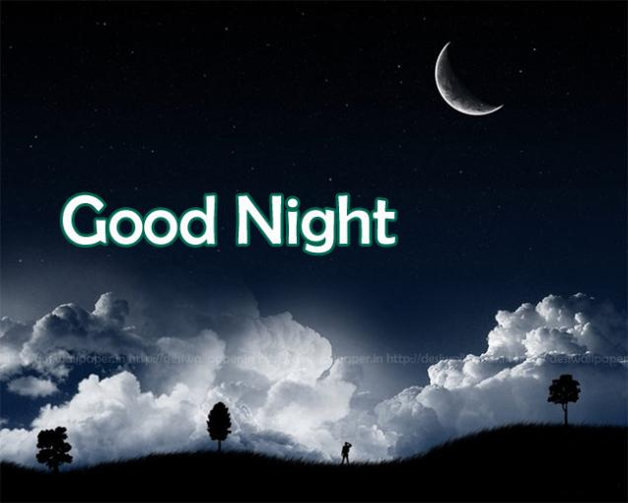
Buenas tardes Buenos días Buenas noches

- Can you draw an emoji demonstrating the following Spanish feelings…?
Fatal
Mal
Bien
Muy Bien
Estuendo

Challenge: If you like you could draw a comic picture with 2 characters greeting each other in Spanish!!

