Wednesday 1st April
LO: Read and draw simple pictograms and tally charts and answer questions about the data.
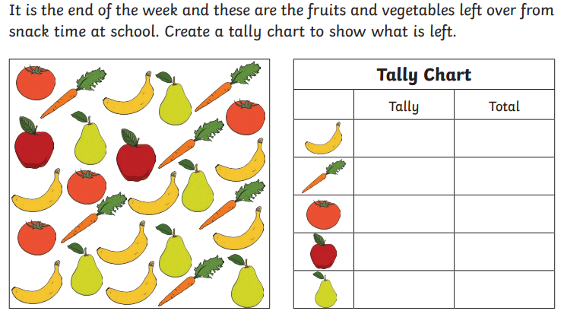
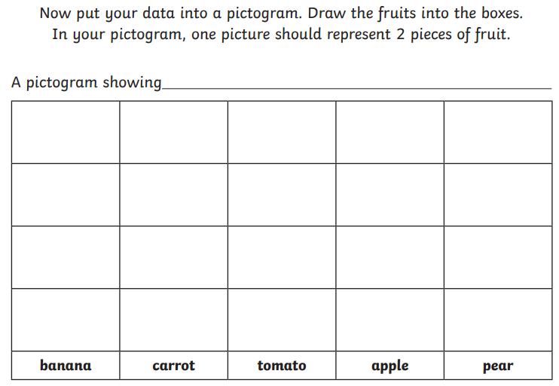
Extension
Now use your tally chart and pictogram to answer questions about the information.

- How many bananas were left?
- How many pears were left?
- How many tomatoes and carrots were left altogether?
- Which fruit had the fewest number of pieces left?
- How many more bananas were there than apples?
- How many pieces of fruit were left altogether?

