Wednesday 1st March
LO: To write a set of instructions
Success Criteria
- Include a title
- Use ‘bossy’ imperative verbs
- Order instructions correctly
- Use adverbs and time connectives

Before you begin, wash your hands as well as you can. Think carefully about what you are doing at each step.

Extension

Draw small clear pictures to go with each instruction.

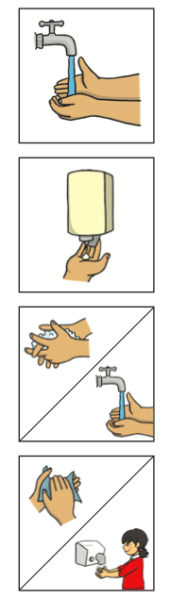
How to Wash Your Hands

- Turn on the tap.

2.

3.

4.
Word Bank
Bossy’ Verbs (imperative verbs) | Adverbs | Time Connectives | Key words
Put  Pick up  Push  Turn | Gently  Carefully | Then  Next  After that  Finally | Water  Soap  Tap  Scrub  Between  Fingers

