1. Click on the world icon, this will then ‘publish’

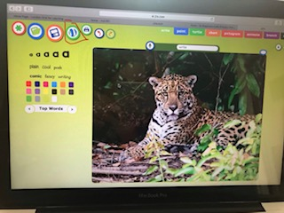

2. Go back onto launch and click on the world icon.
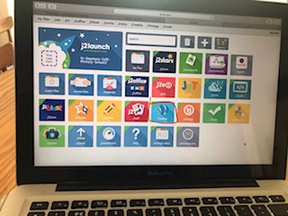

3. Click on blogs and select your class
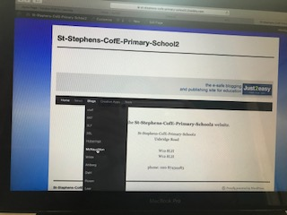

4. Click on your title on the right. You should see the sloth fact file I did the other day, along with the fact files others in the class have created!

