Parents, I apologize in advance about the size of the photos, I have had issues with the size of the images hence having to keep them small.

- Login to USO

- Click on resources

- Click on JIT

- Click on JIT5

- Click on pictures
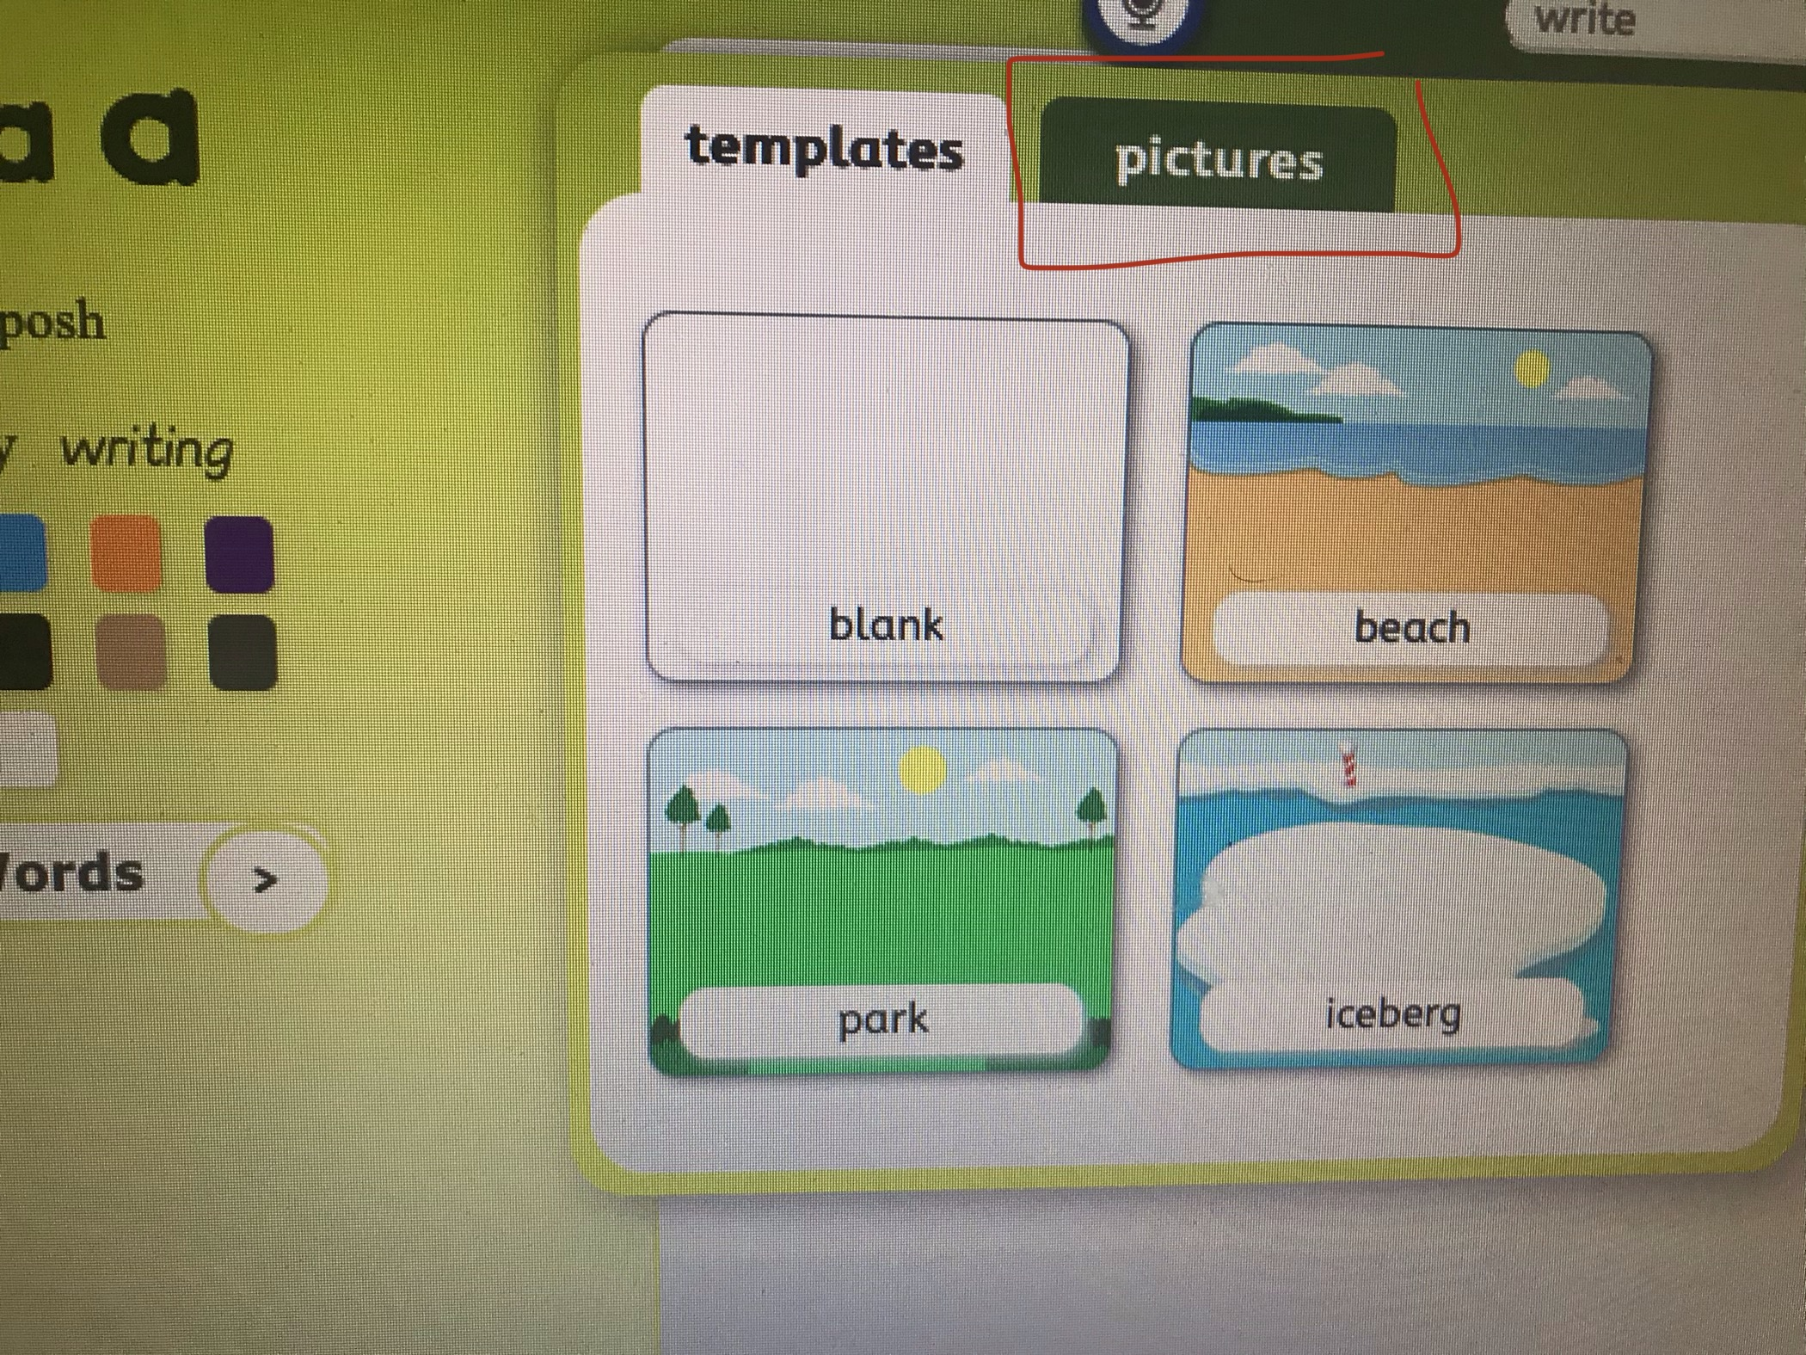

- Click on the icon with 3 people

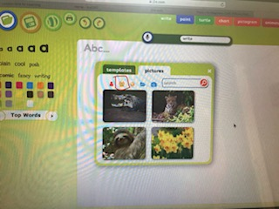
- Choose from either the picture of the sloth, the jaguar or the caiman (alternatively the children can add their own photo)
- This will load the page and the children can write over the top of the image.
- Press save and print if you wish!

