Children’s books to initiate discussion about race and racism….
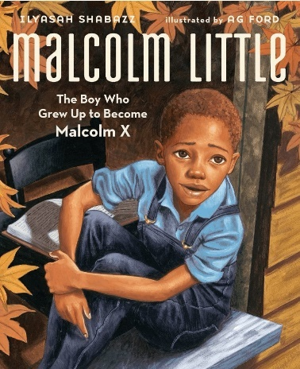 | 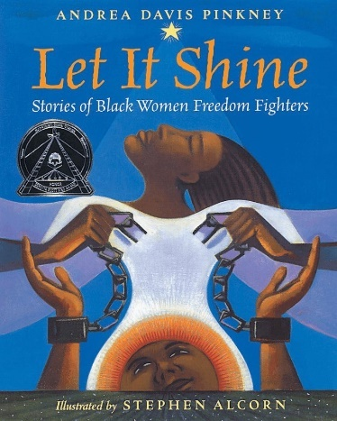
- Malcolm X grew to be one of America’s most influential figures. But first, he was a boy named Malcolm Little. Written by his daughter, this inspiring picture book biography celebrates a vision of freedom and justice. | - Rosa Parks refused to give up her seat on a bus and sparked a boycott that changed America. Harriet Tubman helped more than three hundred slaves escape the South on the Underground Railroad. Shirley Chisholm became the first black woman elected to the U.S. House of Representatives. The lives these women led are part of an incredible story about courage in the face of oppression; about the challenges and triumphs of the battle for civil rights; and about speaking out for what you believe in--even when it feels like no one is listening
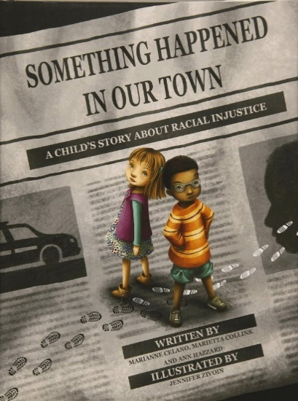 | 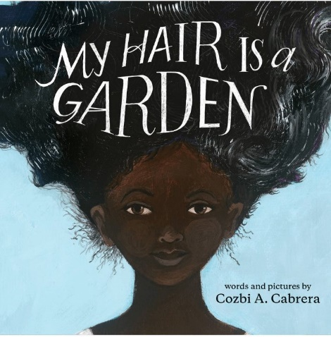
- A Black man was shot by the police. "Why did the police shoot that man?" "Can police go to jail?" Something Happened in Our Town follows two families — one White, one Black — as they discuss a police shooting of a Black man in their community. The story aims to answer children's questions about such traumatic events, and to help children identify and counter racial injustice in their own lives. | - After a day of being taunted by classmates about her unruly hair, Mackenzie can't take any more and she seeks guidance from her wise and comforting neighbor, Miss Tillie. Using the beautiful garden in the backyard as a metaphor, Miss Tillie shows Mackenzie that maintaining healthy hair is not a chore nor is it something to fear. Most importantly, Mackenzie learns that natural black hair is beautiful.
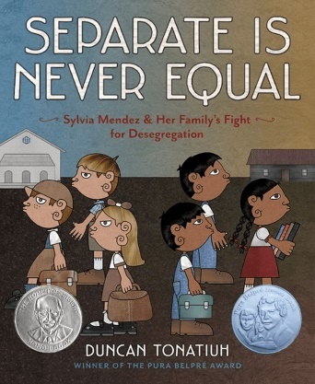 | 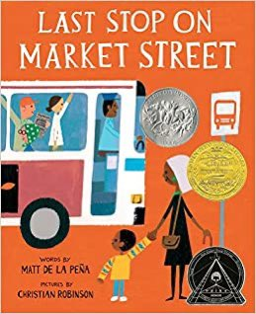
- Separate is Never Equal is a book set in the United States about a Hispanic family (all US citizens) who were not allowed to attend a white school. This book is a factual book about the first fight for the desegregation of the public schools. | - Last Stop on Market Street is an inspirational and heart warming picture book about an ordinary Sunday for CJ and his grandma. As they go about their normal routine--church, walk, bus stop, bus ride, walk, soup kitchen--they encounter other people who have more (and less) than they do.
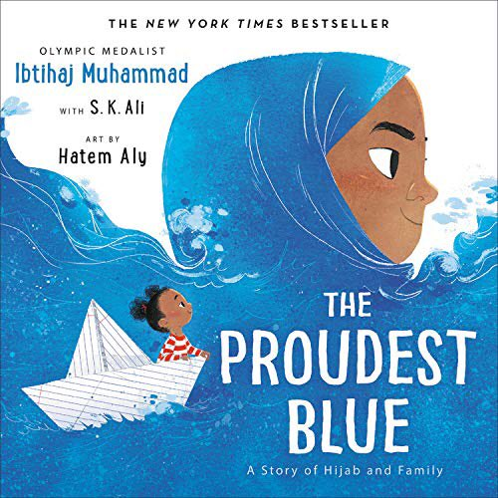 | 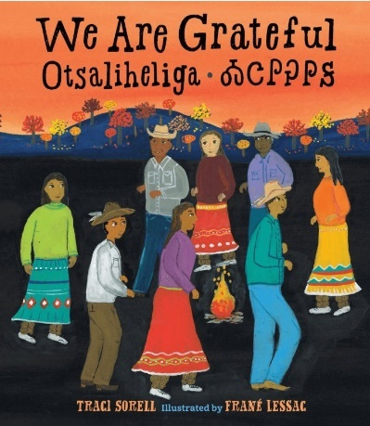
- A powerful, vibrantly illustrated story about the first day of school--and two sisters on one's first day of hijab--by Olympic medalist and social justice activist Ibtihaj Muhammad. With her new backpack and light-up shoes, Faizah knows the first day of school is going to be special. It's the start of a brand new year and, best of all, it's her older sister Asiya's first day of hijab--a hijab of beautiful blue fabric, like the ocean waving to the sky. But not everyone sees hijab as beautiful, and in the face of hurtful, confusing words, Faizah will find new ways to be strong. | - By focusing on the simple but deeply meaningful theme of gratitude, she's portrayed the strength and lasting nature of her Cherokee heritage in a way that will resonate with young readers of many cultural backgrounds
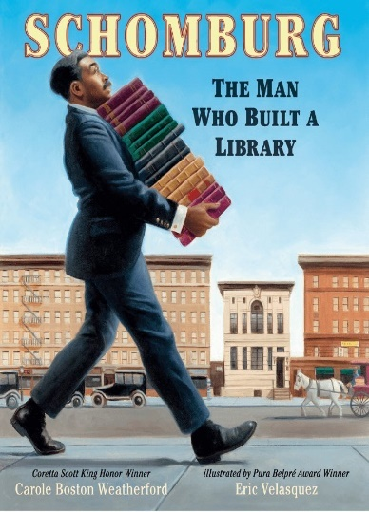 | 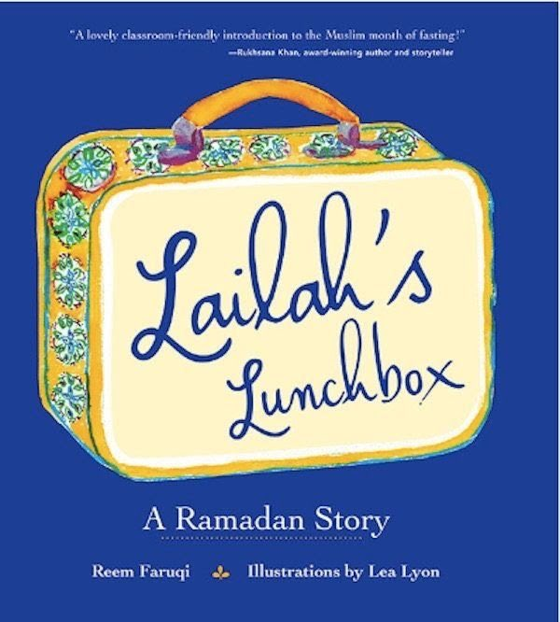
- Amid the scholars, poets, authors, and artists of the Harlem Renaissance stood an Afro-Puerto Rican man named Arturo Schomburg. His life's passion was to collect books, letters, music, and art from Africa and the African diaspora in order to bring to light the achievements of people of African descent. When his collection became so large that it threatened to overflow his house, he turned to the New York Public Library. | - A lovely introduction to the Muslim month of fasting!--Ruhksana Khan, award-winning author and storyteller. If you're looking for an introduction to Ramadan for young readers (ages 5 to 8), consider this picture book.
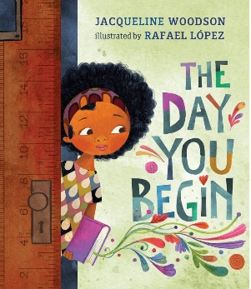 | 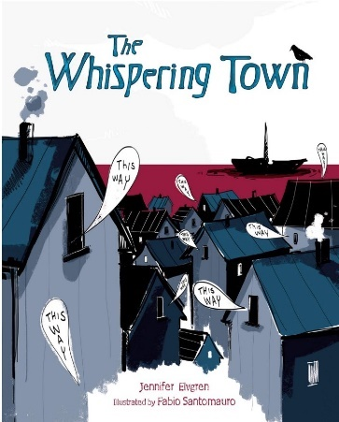
11. The Day You Begin by Jacqueline Woodson and illustrated by Rafael Lopez (Nancy Paulsen Books, 2018) is a beautiful portrayal of what it feels like to be an outsider, to grapple with differences in a world that can be cruel. | 12. The dramatic story of neighbours in a small Danish fishing village who, during the Holocaust, shelter a Jewish family waiting to be ferried to safety in Sweden. It is 1943 in Nazi-occupied Denmark. Anett and her parents are hiding a Jewish woman and her son, Carl, in their cellar until a fishing boat can take them across the sound to neutral Sweden.
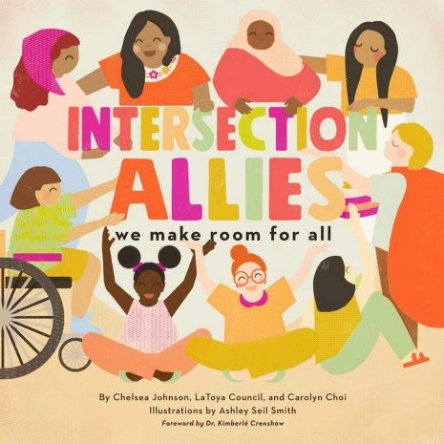 | 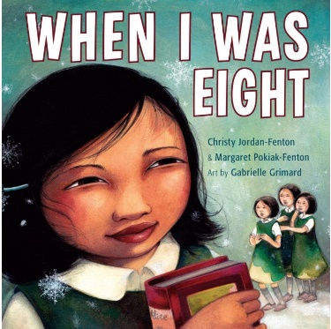
13. "Intersection Allies reminds us that we don't have to "choose" one primary identity. Instead, each of us is all of who we are every single day and in every single way." | 14. When I Was Eight is a picture book adaptation of the early/middle grade chapter book Fatty Legs, telling the true story of Olemaun (Margaret) Pokiak as she ventures into the dangerous territory of residential schools in northern Canada.
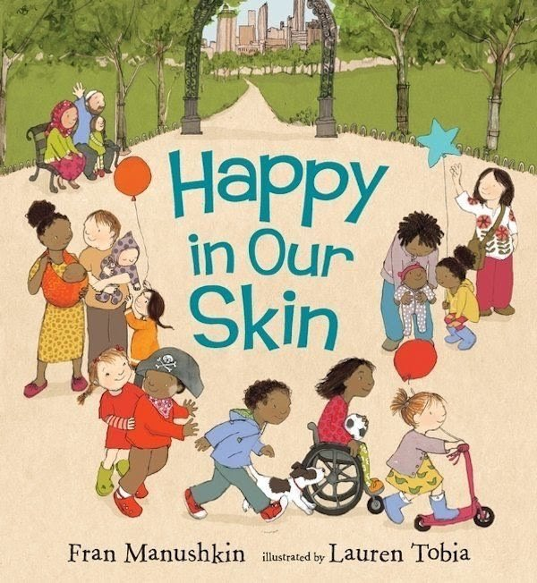 | 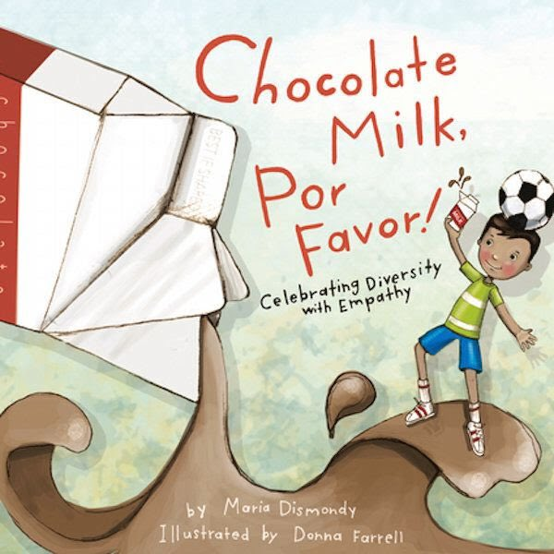
15. “A cheeky meditation on the everyday miraculousness of skin. . . . It’s freewheeling fun.” — Publishers Weekly Is there anything more splendid than a baby’s skin? Cocoa-brown, cinnamon, peaches and cream. As children grow, their clever skin does, too, enjoying hugs and tickles, protecting them inside and out, and making them one of a kind. | 16. It's Gabe's first day of school in America, and he doesn't speak English. This story shows how a simple act of kindness is worth more than a thousand words. Kindness really is a universal language.

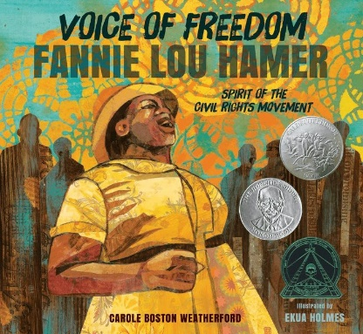 | 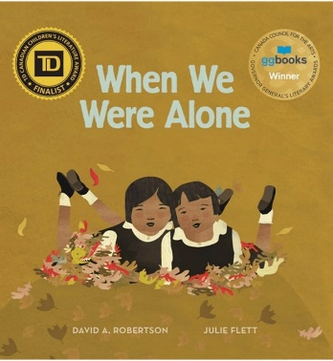
17. Award Winner Stirring poems and stunning collage illustrations combine to celebrate the life of Fannie Lou Hamer, a champion of equal voting rights. | When a young girl helps tend to her grandmother's garden, she begins to notice things that make her curious. Why does her grandmother have long braided hair and beautifully colored clothing? Why does she speak another language and spend so much time with her family? As she asks her grandmother about these things, she is told about life in a residential school a long time ago, where all of these things were taken away. When We Were Alone is a story about a difficult time in history and, ultimately, one of empowerment and strength.18.
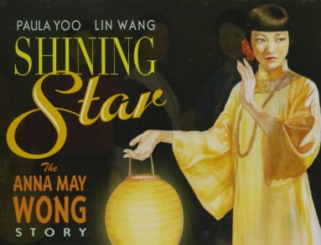 | 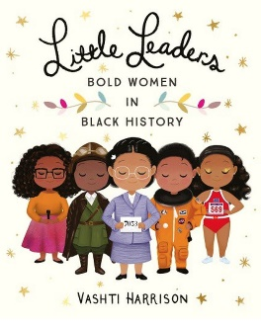
19. The true story of Chinese American film star Anna May Wong, whose trail-blazing career in Hollywood in the 1930s and 1940s broke new ground for future generations of Asian American actors. | 20. Little Leaders: Bold Women in Black History is the debut book from Vashti Harrison. Based on her popular Instagram posts from Black History Month 2017 it features 40 biographies of African American women that helped shape history.
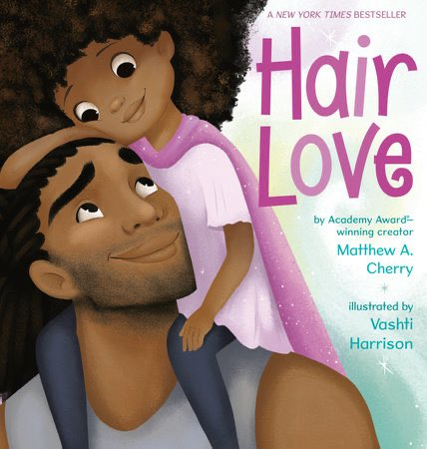 | 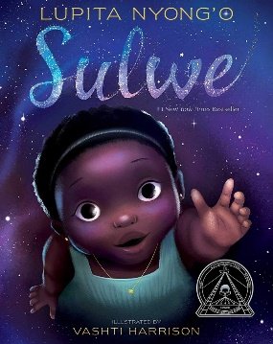
21. Based upon a film of the same name, also written by Matthew A. Cherry, and due out later this year (2019), Hair Love is a sweet picture-book about a little African-American girl who is determined to have a very special hairdo for a very special occasion. Her father steps in to help, and after some trial and error, they produce just what she's been looking for | 22. Sulwe is a children's fiction picture book by actress Lupita Nyong'o. It follows the story of a young girl who wishes for her dark skin to be lighter. The story is ultimately about colorism and learning to love oneself, no matter one's skin tone.
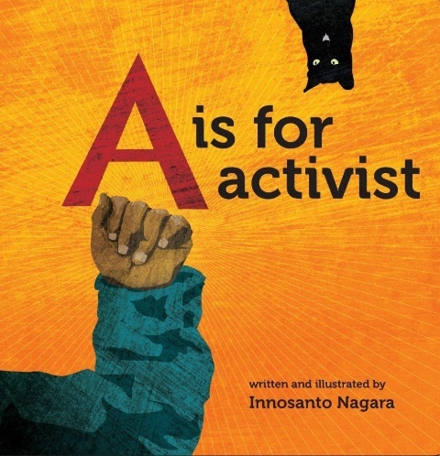
23. A is for Activist is a bestselling children's alphabet board book by Innosanto Nagara. His debut as both an author and an illustrator, he initially wrote it for his children out of a desire for a political yet educational book

