Children’s books dealing with bereavement….
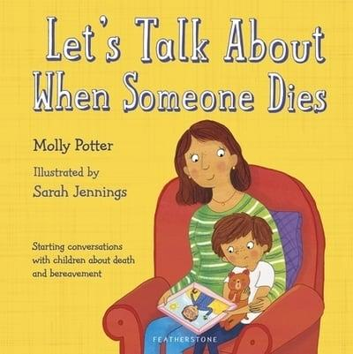 | 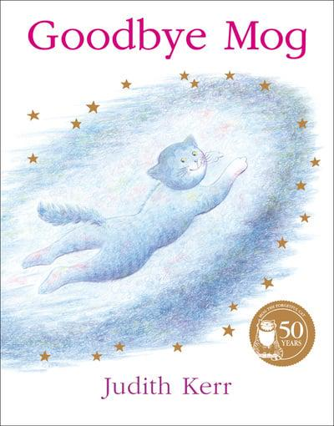
- Open discussion about berevement- highly reccomended | - Story involving berevement
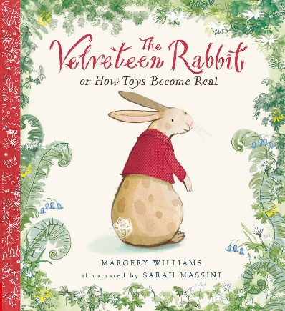 | 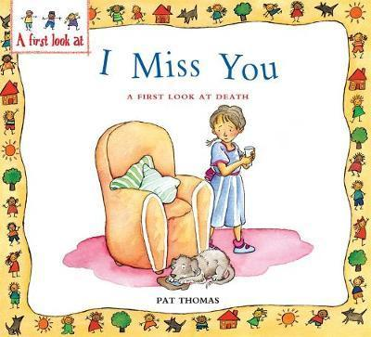
- Story involving loss | - I Miss You: A First Look At Death is a book that helps children who have lost a loved one, learn how to cope with grieving. It helps them to understanding the emotions they are feeling and to let them know that its normal to feel that way when losing someone they love.
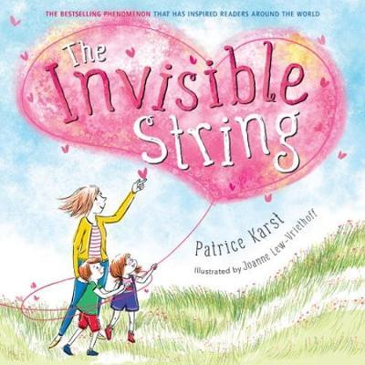 | 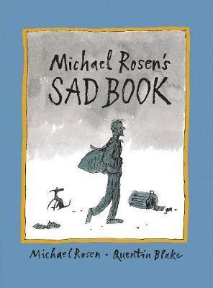
- Parents, educators, therapists, and social workers alike have declared The Invisible String the perfect tool for coping with all kinds of separation anxiety, loss, and grief. In this relatable and reassuring contemporary classic, a mother tells her two children that they're all connected by an invisible string. | - The book's topic is dealing with grief. Although it is marketed as a children's book, Rosen explicitly mentions on the inside book jacket that it is for everyone. Better for upper KS2. Very sad.
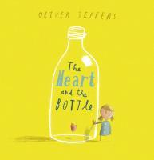 | 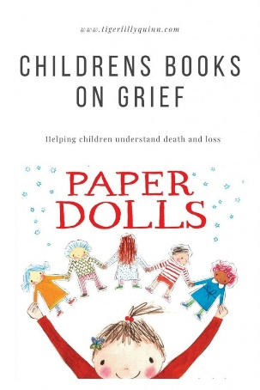
- An inquisitive little girl, who is enchanted by the world around her, is badly shaken when she loses someone she loves. | - Paper Dolls is about a girl who makes paper dolls with her mother and takes them on adventures around the house and garden. A boy snips them to pieces with his scissors, but the dolls don't disappear. Instead, they go into the girl's memory.
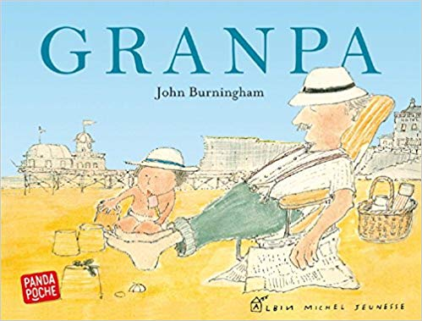 | 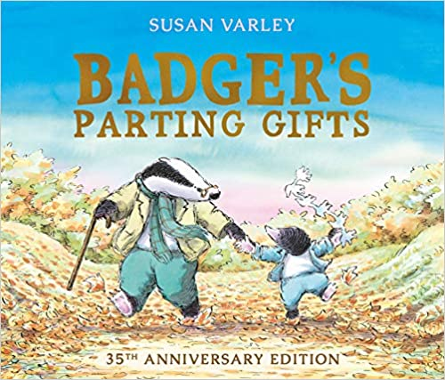
- Granpa nurses his granddaughter's dolls, mistakes her strawberry-flavoured pretend ice-cream for chocolate, takes her tobogganing in the snow, and falls in with her imaginary plans to captain a ship to Africa, like all good Granpa's should. It is a friendship that children who read this book will long remember. Deals less with bereavement and more with th importance of spending time with loved ones. | - A succesful book that deals gently and clearly with issues of loss and death for young children. Now 35 years old, Badger's Parting Gifts has been used by countless families experiencing bereavement to help talk about their feelings.

